Information Security

Assignment 03

Name: Hafsa Shakeel
20L-1339
BSDS-7A

Q1:

A:

Log filter for Audit Failures:
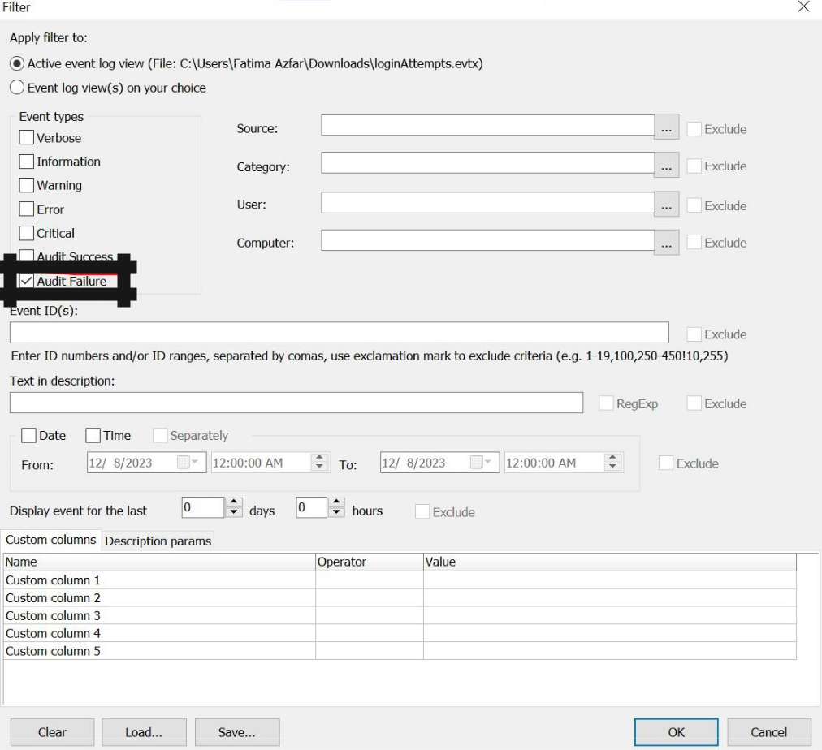

The resulting filter output are concurrent failed logon attempts.
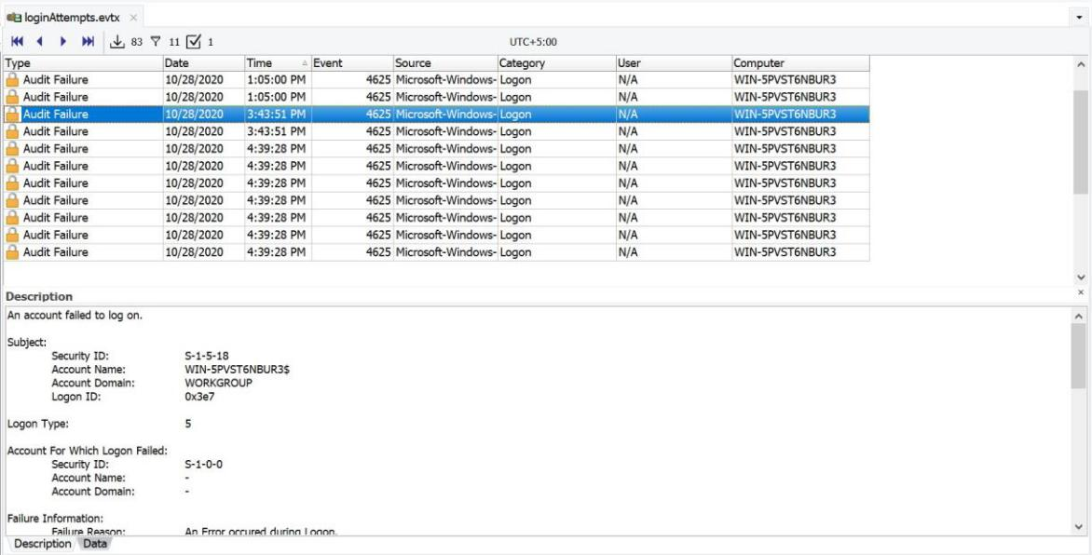

P B

This is the account that is constantly being attacked:
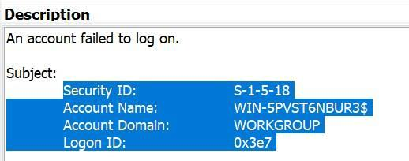
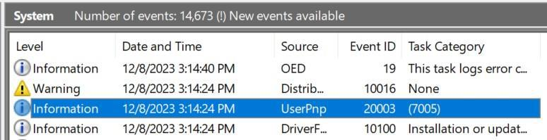

P C

This is the time range of the attacks is from 1:05:00 PM till 4:39:28 PM in the same day
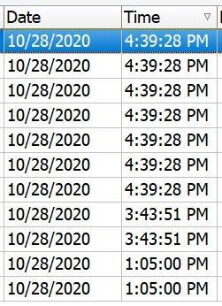

Q2:

P A
The USB activity is indicated by the Event ID 20003 and the source UserPnp:

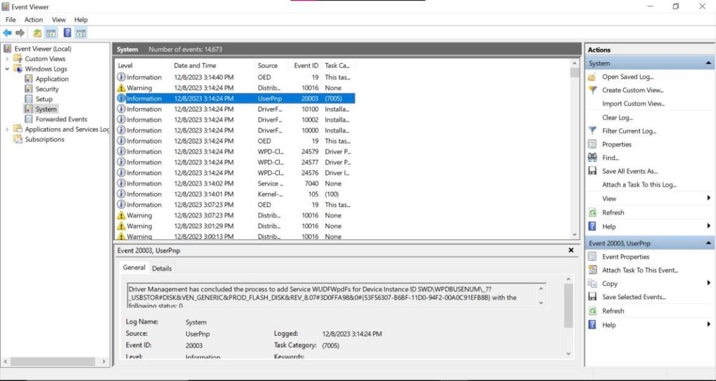

P B
The actions that happened when I installed mysql server on my computer are the ones I have highlighted.

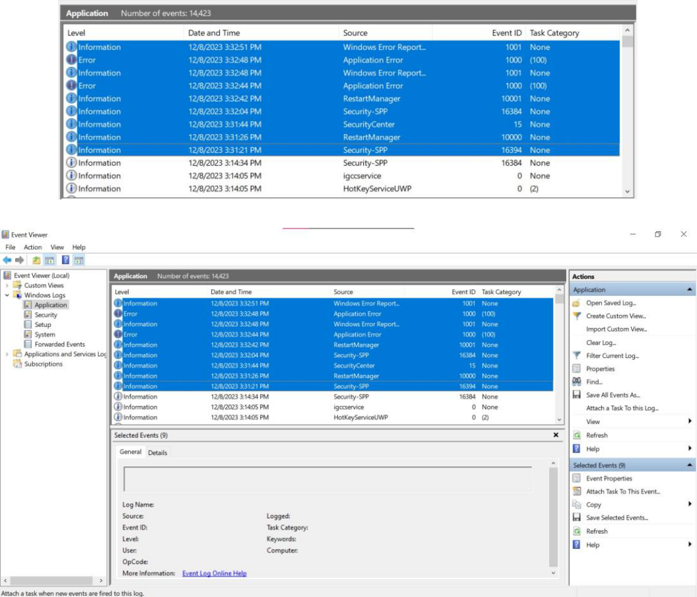

P C

So, I changed the user account control settings to mute notifications
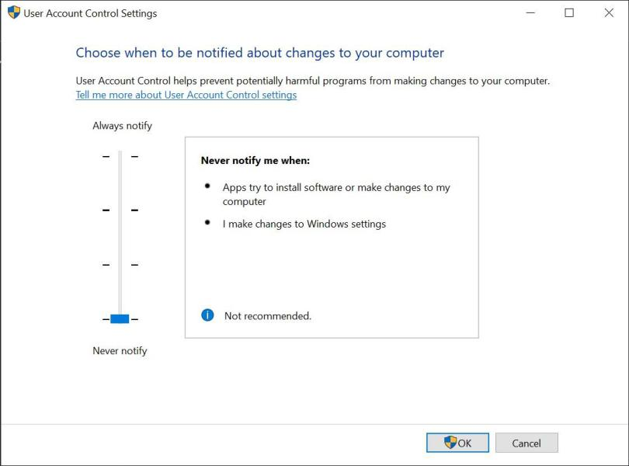

These events took place on changing the UAC:
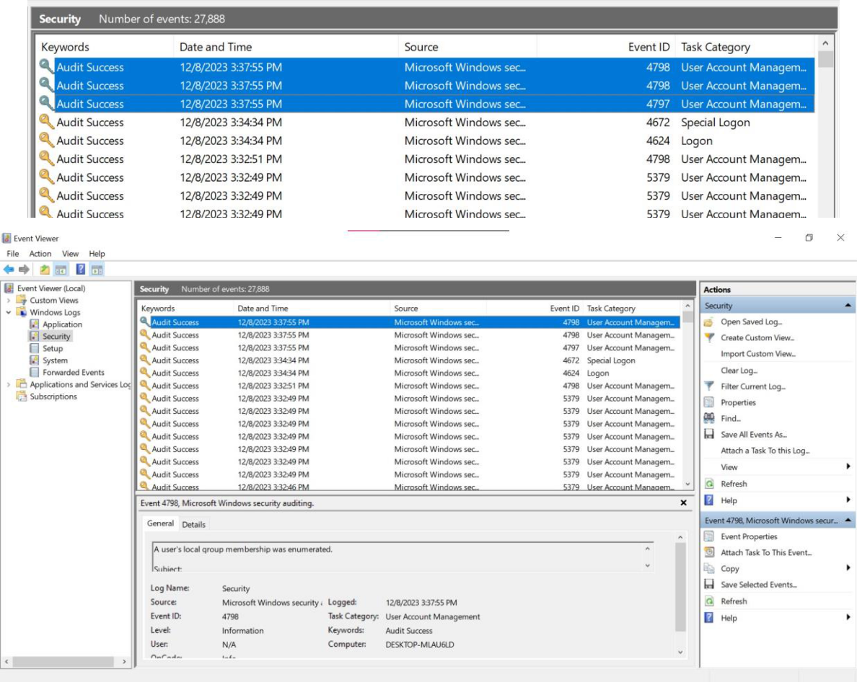

P D

I turned off the real-time protection from windows security settings:
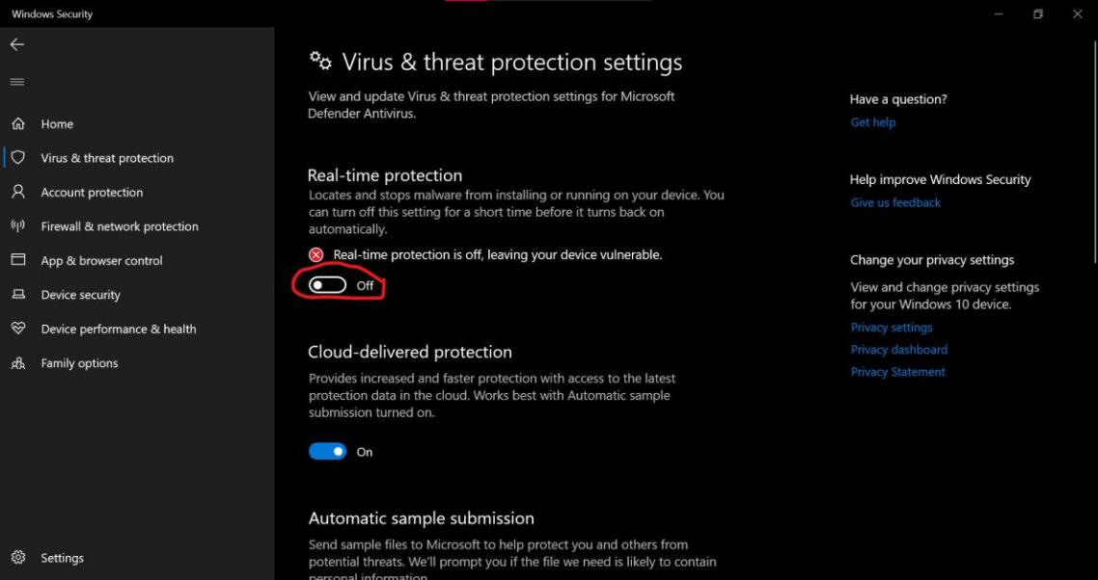

Then I checked the event viewer and these events that took place:

